Host Portion
# Source: Chatgpt (GPT-5-Mini) at [1/18/2026]
The host portion is the part of an IP address that identifies a specific device (host) within a given network.
It’s determined by the subnet mask or CIDR prefix, which tells you how many bits are used for the network — and the rest are used for hosts.

🧠 Simple Definition:
# Source: Chatgpt (GPT-5-Mini) at [1/18/2026]
The host portion is the remaining part of an IP address (after the network portion) that identifies individual devices on the network.

🧾 Example:
# Source: Chatgpt (GPT-5-Mini) at [1/18/2026]
Given:
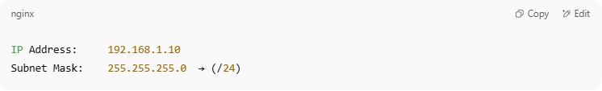
IP Address: 192.168.1.10
Subnet Mask: 255.255.255.0 → (/24)

Binary Breakdown:
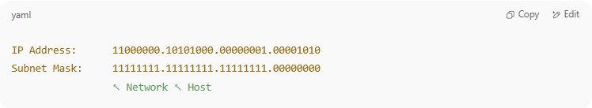
IP Address: 11000000.10101000.00000001.00001010
Subnet Mask: 11111111.11111111.11111111.00000000
↖ Network ↖ Host

- Network portion = first 24 bits → 192.168.1
- Host portion = last 8 bits → 10
So 192.168.1.10:
- Belongs to network 192.168.1.0/24
- Device ID is 10 in that network

🧱 How It Works:
# Source: Chatgpt (GPT-5-Mini) at [1/18/2026]
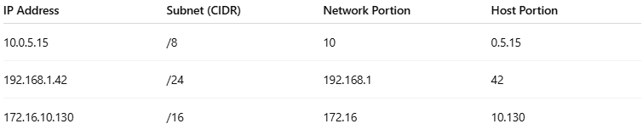
IP Address | Subnet (CIDR) | Network Portion | Host Portion
10.0.5.15 | /8 | 10 | 0.5.15
192.168.1.42 | /24 | 192.168.1 | 42
172.16.10.130 | /16 | 172.16 | 10.130

🛑 Host Portion Rules:
# Source: Chatgpt (GPT-5-Mini) at [1/18/2026]
- All 0s = Network address (e.g. 192.168.1.0)
- All 1s = Broadcast address (e.g. 192.168.1.255)
- So, these two are not assignable to devices

📦 Summary
# Source: Chatgpt (GPT-5-Mini) at [1/18/2026]
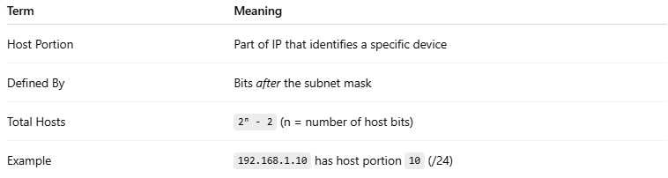
Term | Meaning
Host Portion | Part of IP that identifies a specific device
Defined By | Bits after the subnet mask
Total Hosts | 2ⁿ - 2 (n = number of host bits)
Example | 192.168.1.10 has host portion 10 (/24)

